REPRESENTATIVE TRACK AND TRACE APPLICATION SCOPE
UPDATED ILLUSTRATION
- Rep Phone Application Form
Sales Stock File

Select Shop
Pre-Populated:
- Shop Address
- Manager Name
- Manager Phone Number

Select Product
Take a picture of the stock file

Enter Quantity from Stock file
Enter Current Quantity Found

Automatic Discrepancy displays
Comment / Resolution

Take a picture of the P.O if Applicable

Save as Draft

Merchandizing
Take a before picture (5 photos )

Take a After picture (5 photos )

Save as Draft
Submit
Comment

- Admin Important Report
Individual reps reports.
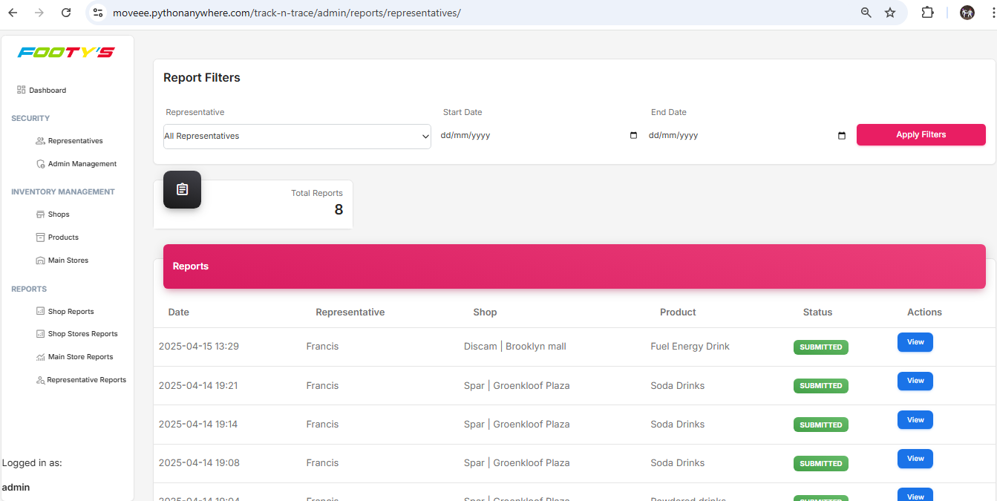
Download
Download
Download
Download

